Chapter 13. Creating a Content Management System

In the previous chapter, you created the application models for the e-learning platform and learned how to create and apply data fixtures for models. You created a custom model field to order objects and implemented user authentication.

In this chapter, you will learn how to build the functionality for instructors to create courses and manage the contents of those courses in a versatile and efficient manner.

You will be introduced to class-based views, which offer a new perspective to build your application compared to the function-based views you have built in previous examples. You will also explore code reusability and modularity through the use of mixins, which are techniques that you can apply in future projects.

In this chapter, you will learn how to:

- Create a content management system (CMS) using class-based views and mixins

- Build formsets and model formsets to edit course modules and module contents

- Manage groups and permissions

- Implement a drag-and-drop functionality to reorder modules and content

Functional overview
Figure 13.1 shows a representation of the views, templates, and functionalities that will be built in this chapter:
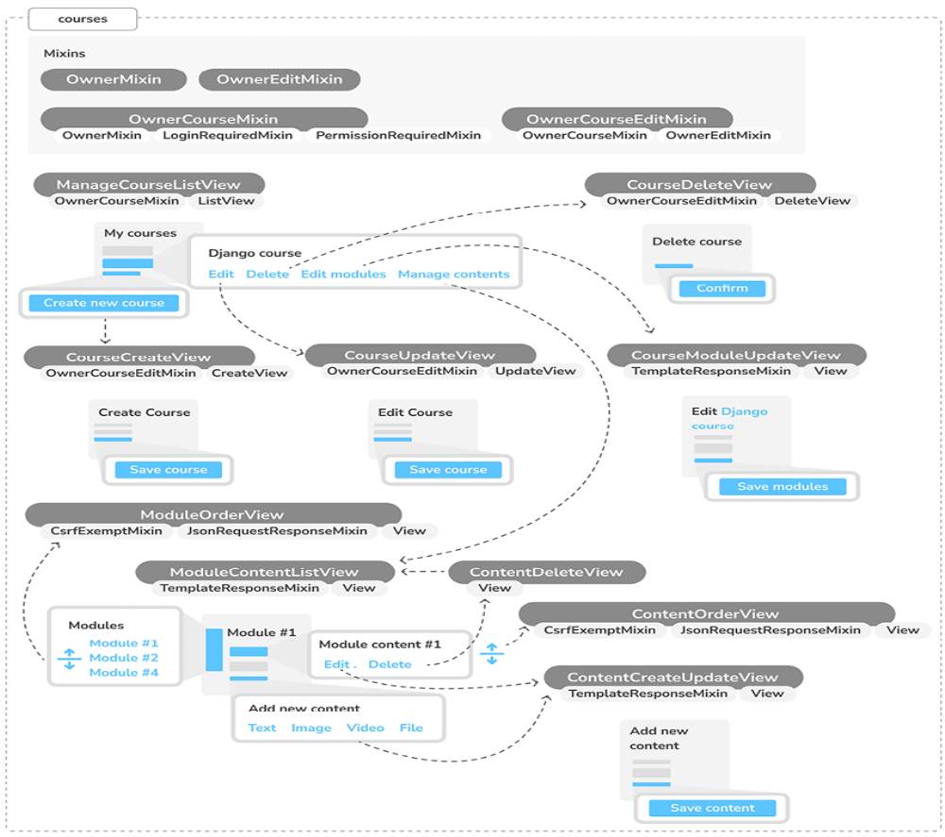
Figure 13.1: Diagram of functionalities built in Chapter 13
In this chapter, you will implement different class-based views. You will create the mixin classes OwnerMixin , OwnerEditMixin , and OwnerCourseMixin , which will contain common functionality that you will reuse in other classes. You will create CRUD (Create, Read, Update, Delete) views for the Course model by implementing ManageCourseListView to list courses, CourseCreateView to create courses, CourseUpdateView to update courses, and CourseDeleteView to delete courses. You will build the CourseModuleUpdateView view to add/edit/delete course modules and ModuleContentListView to list the module’s contents. You will also implement ContentCreateUpdateView to create and update course contents
and ContentDeleteView to delete contents. You will finally implement a drag-and-drop functionality to reorder course modules and contents using the ModuleOrderView and ContentOrderView views, respectively.

Note that all views that inherit the mixin OwnerCourseMixin redirect the user back to the ManageCourseListView view after a successful action. These redirects have not been added to the diagram for simplicity.

The source code for this chapter can be found at
https://github.com/PacktPublishing/Django-5-byexample/tree/main/Chapter13.

All Python modules used in this chapter are included in the requirements.txt file in the source code that comes along with this chapter. You can follow the instructions to install each Python module below or you can install all the requirements at once with the command python -m pip install -r requirements.txt .

Creating a CMS
Now that you have created a versatile data model, you are going to build the CMS. The CMS will allow instructors to create courses and manage their
content. You need to provide the following functionality:

- List the courses created by the instructor
- Create, edit, and delete courses
- Add modules to a course and reorder them
- Add different types of content to each module
- Reorder course modules and content

Let’s start with the basic CRUD views.

Creating class-based views
You are going to build views to create, edit, and delete courses. You will use class-based views for this. Edit the views.py file of the courses application and add the following code:
from django.views.generic.list import ListView
from .models import Course
class ManageCourseListView(ListView):
model = Course
template_name = 'courses/manage/course/list.html'
def get_queryset(self):
qs = super().get_queryset()
return qs.filter(owner=self.request.user)

This is the ManageCourseListView view. It inherits from Django’s generic ListView . You override the get_queryset() method of the view to retrieve only courses created by the current user. To prevent users from editing, updating, or deleting courses they didn’t create, you will also need to override the get_queryset() method in the create, update, and delete views.
When you need to provide a specific behavior for several class-based views, it is recommended that you use mixins.

Using mixins for class-based views
Mixins are a special kind of multiple inheritance for a class. If you are new to mixins in Python, all you need to understand is that they are a type of class designed to supply methods to other classes but aren’t intended to be used independently. This allows you to develop shared functionalities that can be incorporated into various classes in a modular manner, simply by having those classes inherit from mixins. The concept is similar to a base class but you can use multiple mixins to extend the functionality of a given class.

There are two main situations for using mixins:

- You want to provide multiple optional features for a class

- You want to use a particular feature in several classes

Django comes with several mixins that provide additional functionality to your class-based views. You can learn more about mixins at
https://docs.djangoproject.com/en/5.0/topics/classbased-views/mixins/.

You are going to implement a common behavior for multiple views in mixin classes and use it for the course views. Edit the views.py file of the courses application and modify it as follows:
from django.urls import reverse_lazy
from django.views.generic.edit import CreateView, DeleteView, Up
from django.views.generic.list import ListView
from .models import Course
class OwnerMixin:
def get_queryset(self):
qs = super().get_queryset()
return qs.filter(owner=self.request.user)
class OwnerEditMixin:
def form_valid(self, form):
form.instance.owner = self.request.user
return super().form_valid(form)
class OwnerCourseMixin(OwnerMixin):
model = Course
fields = ['subject', 'title', 'slug', 'overview']
success_url = reverse_lazy('manage_course_list')
class OwnerCourseEditMixin(OwnerCourseMixin, OwnerEditMixin):
template_name = 'courses/manage/course/form.html'
class ManageCourseListView(OwnerCourseMixin, ListView):
template_name = 'courses/manage/course/list.html'
class CourseCreateView(OwnerCourseEditMixin, CreateView):
pass
class CourseUpdateView(OwnerCourseEditMixin, UpdateView):
pass
class CourseDeleteView(OwnerCourseMixin, DeleteView):
template_name = 'courses/manage/course/delete.html'

In this code, you create the OwnerMixin and OwnerEditMixin mixins. You will use these mixins together with the ListView , CreateView , UpdateView , and DeleteView views provided by Django. OwnerMixin implements the get_queryset() method, which is used by the views to get the base
QuerySet. Your mixin will override this method to filter objects by the owner attribute to retrieve objects that belong to the current user (request.user ).

OwnerEditMixin implements the form_valid() method, which is used by views that use Django’s ModelFormMixin mixin – that is, views with forms or model forms such as CreateView – and UpdateView . form_valid() is executed when the submitted form is valid.

The default behavior for this method is saving the instance (for model forms) and redirecting the user to success_url . You override this method to automatically set the current user in the owner attribute of the object being saved. By doing so, you set the owner for an object automatically when it is saved.

Your OwnerMixin class can be used for views that interact with any model that contains an owner attribute.

You also define an OwnerCourseMixin class that inherits OwnerMixin and provides the following attributes for child views:

- model : The model used for QuerySets; it is used by all views.

- fields : The fields of the model to build the model form of the CreateView and UpdateView views.

- success_url : Used by CreateView , UpdateView , and DeleteView to redirect the user after the form is successfully submitted or the object is deleted. You use a URL with the name manage_course_list , which you are going to create later.

You define an OwnerCourseEditMixin mixin with the following attribute:

- template_name : The template you will use for the CreateView and UpdateView views.

Finally, you create the following views that subclass OwnerCourseMixin :

- ManageCourseListView : Lists the courses created by the user. It inherits from OwnerCourseMixin and ListView . It defines a specific template_name attribute for a template to list courses.

- CourseCreateView : Uses a model form to create a new Course object. It uses the fields defined in OwnerCourseMixin to build a model form and also subclasses CreateView . It uses the template defined in OwnerCourseEditMixin .

- CourseUpdateView : Allows the editing of an existing Course object. It uses the fields defined in OwnerCourseMixin to build a model form and also subclasses UpdateView . It uses the template defined in OwnerCourseEditMixin .

- CourseDeleteView : Inherits from OwnerCourseMixin and the generic DeleteView . It defines a specific template_name attribute for a template to confirm the course deletion.

You have created the basic views to manage courses. While you have implemented CRUD views on your own, the third-party application Neapolitan allows you to implement the standard list, detail, create, and delete views within a single view. You can learn more about Neapolitan at https://github.com/carltongibson/neapolitan.

Next, you are going to use Django authentication groups and permissions to limit access to these views.

Working with groups and permissions
Currently, any user can access the views to manage courses. You want to restrict these views so that only instructors have permission to create and manage courses.

Django’s authentication framework includes a permission system. By default, Django generates four permissions for each model in the installed applications: add , view , change , and delete . These permissions correspond to the actions of creating new instances, viewing existing ones, editing, and deleting instances of a model.

Permissions can be assigned directly to individual users or groups of users. This approach simplifies user management by grouping permissions and enhances the security of your application.

You are going to create a group for instructor users and assign permissions to create, update, and delete courses.
Run the development server using the following command:
python manage.py runserver

Open http://127.0.0.1:8000/admin/auth/group/add/ in your browser to create a new Group object. Add the name Instructors and choose all permissions of the courses application, except those of the Subject model, as follows:
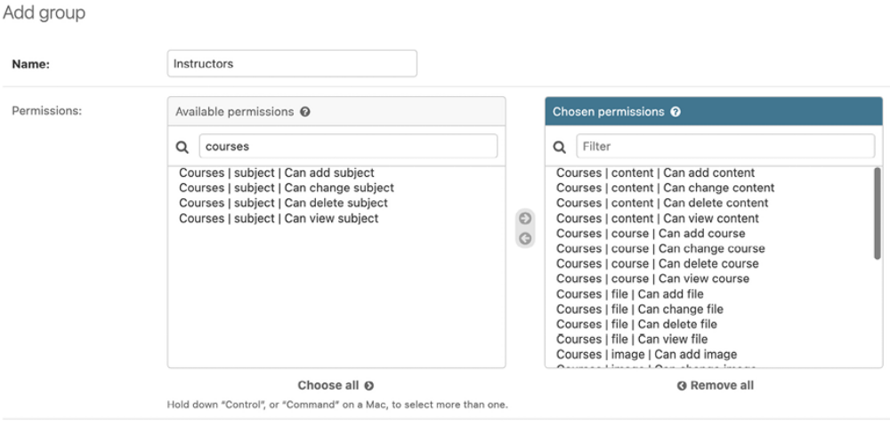
Figure 13.2: The Instructors group permissions
As you can see, there are four different permissions for each model: can view, can add, can change, and can delete. After choosing permissions for this group, click the SAVE button.

Django creates permissions for models automatically but you can also create custom permissions. You will learn how to create custom permissions in Chapter 15, Building an API. You can read more about adding custom permissions at
https://docs.djangoproject.com/en/5.0/topics/auth/customizing/#custom-permissions.

Open http://127.0.0.1:8000/admin/auth/user/add/ and create a new user.
Edit the user and add it to the Instructors group, as follows:
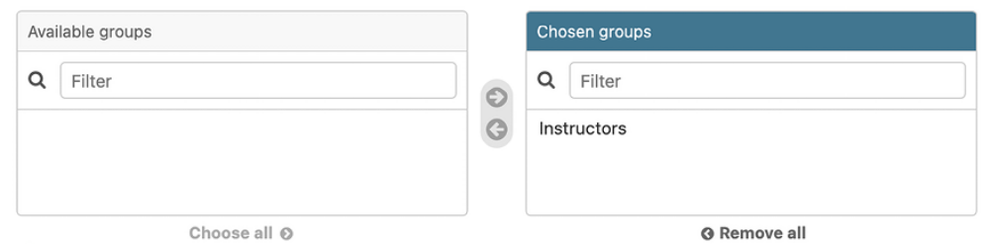
Figure 13.3: User group selection

Users inherit the permissions of the groups they belong to, but you can also add individual permissions to a single user using the administration site. Users that have is_superuser set to True have all permissions automatically.

Next, you will apply permissions in practice by incorporating them into our views.

Restricting access to class-based views
You are going to restrict access to the views so that only users with the appropriate permissions can add, change, or delete Course objects. You are going to use the following two mixins provided by django.contrib.auth to limit access to views:

- LoginRequiredMixin : Replicates the login_required decorator’s functionality.

- PermissionRequiredMixin : Grants access to the view to users with a specific permission. Remember that superusers automatically have all permissions.

Edit the views.py file of the courses application and add the following import:
from django.contrib.auth.mixins import (
LoginRequiredMixin,
PermissionRequiredMixin
)

Make OwnerCourseMixin inherit LoginRequiredMixin and PermissionRequiredMixin , like this:
class OwnerCourseMixin(
OwnerMixin, LoginRequiredMixin, PermissionRequiredMixin
):
model = Course
fields = ['subject', 'title', 'slug', 'overview']
success_url = reverse_lazy('manage_course_list')

Then, add a permission_required attribute to the course views, as follows:
class ManageCourseListView(OwnerCourseMixin, ListView):
template_name = 'courses/manage/course/list.html'
permission_required = 'courses.view_course'
class CourseCreateView(OwnerCourseEditMixin, CreateView):
permission_required = 'courses.add_course'
class CourseUpdateView(OwnerCourseEditMixin, UpdateView):
permission_required = 'courses.change_course'
class CourseDeleteView(OwnerCourseMixin, DeleteView):
template_name = 'courses/manage/course/delete.html'
permission_required = 'courses.delete_course'

PermissionRequiredMixin checks that the user accessing the view has the permission specified in the permission_required attribute. Your views are now only accessible to users with the proper permissions.
Let’s create URLs for these views. Create a new file inside the courses application directory and name it urls.py . Add the following code to it:
from django.urls import path
from . import views
urlpatterns = [
path(
'mine/',
views.ManageCourseListView.as_view(),
name='manage_course_list'
),
path(
'create/',
views.CourseCreateView.as_view(),
name='course_create'
),
path(
'<pk>/edit/',
views.CourseUpdateView.as_view(),
name='course_edit'
),
path(
'<pk>/delete/',
views.CourseDeleteView.as_view(),
name='course_delete'
),
]

These are the URL patterns for the list, create, edit, and delete course views. The pk parameter refers to the primary key field. Remember that pk is short for primary key. Every Django model has a field that serves as its primary key. By default, the primary key is the automatically generated id field. The Django generic views for single objects retrieve an object by its pk field.
Edit the main urls.py file of the educa project and include the URL patterns
of the courses application, as follows.
New code is highlighted in bold:
from django.conf import settings
from django.conf.urls.static import static
from django.contrib import admin
from django.contrib.auth import views as auth_views
from django.urls import include, path
urlpatterns = [
path(
'accounts/login/', auth_views.LoginView.as_view(), name=
),
path(
'accounts/logout/',
auth_views.LogoutView.as_view(),
name='logout'
),
path('admin/', admin.site.urls),
path('course/', include('courses.urls')),
]
if settings.DEBUG:
urlpatterns += static(
settings.MEDIA_URL, document_root=settings.MEDIA_ROOT
)

You need to create the templates for these views. Create the following directories and files inside the templates/ directory of the courses application:
courses/
manage/
course/
list.html
form.html
delete.html

Edit the courses/manage/course/list.html template and add the following
code to it:
{% extends "base.html" %}
{% block title %}My courses{% endblock %}
{% block content %}
<h1>My courses</h1>
<div class="module">
{% for course in object_list %}
<div class="course-info">
<h3>{{ course.title }}</h3>
<p>
<a href="{% url "course_edit" course.id %}">Edit</a>
<a href="{% url "course_delete" course.id %}">Delete</a>
</p>
</div>
{% empty %}
<p>You haven't created any courses yet.</p>
{% endfor %}
<p>
<a href="{% url "course_create" %}" class="button">Create new co
</p>
</div>
{% endblock %}

This is the template for the ManageCourseListView view. In this template, you list the courses created by the current user. You include links to edit or delete each course and a link to create new courses.
Run the development server using the following command:
python manage.py runserver

Open http://127.0.0.1:8000/accounts/login/?next=/course/mine/ in your browser and log in with a user belonging to the Instructors group.
After logging in, you will be redirected to the http://127.0.0.1:8000/course/mine/ URL and you should see the following page:
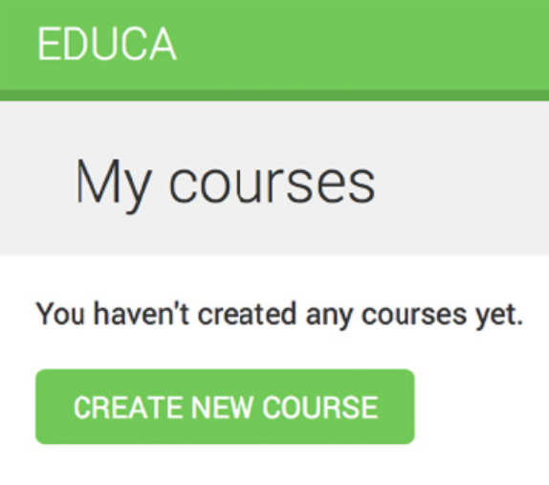
Figure 13.4: The instructor courses page with no courses

This page will display all courses created by the current user.
Let’s create the template that displays the form for the create and update course views. Edit the courses/manage/course/form.html template and write the following code:
{% extends "base.html" %}
{% block title %}
{% if object %}
Edit course "{{ object.title }}"
{% else %}
Create a new course
{% endif %}
{% endblock %}
{% block content %}
<h1>
{% if object %}
Edit course "{{ object.title }}"
{% else %}
Create a new course
{% endif %}
</h1>
<div class="module">
<h2>Course info</h2>
<form method="post">
{{ form.as_p }}
{% csrf_token %}
<p><input type="submit" value="Save course"></p>
</form>
</div>
{% endblock %}

The form.html template is used for both the CourseCreateView and CourseUpdateView views. In this template, you check whether an object variable is in the context. If object exists in the context, you know that you are updating an existing course and you use it in the page title. Otherwise, you are creating a new Course object.

Open http://127.0.0.1:8000/course/mine/ in your browser and click the CREATE NEW COURSE button. You will see the following page:
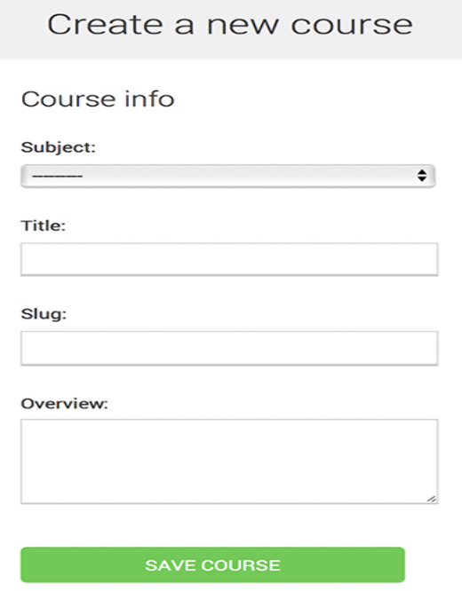
Figure 13.5: The form to create a new course
Fill in the form and click the SAVE COURSE button. The course will be saved and you will be redirected to the course list page. It should look as follows:
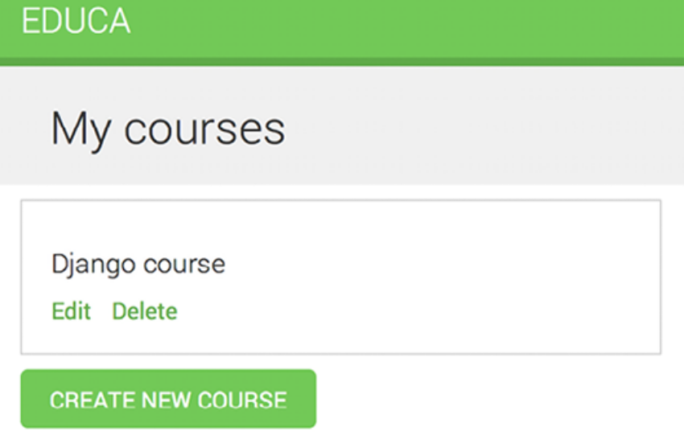
Figure 13.6: The instructor courses page with one course

Then, click the Edit link for the course you have just created. You will see the form again but, this time, you are editing an existing Course object instead of creating one.
Finally, edit the courses/manage/course/delete.html template and add the following code:
{% extends "base.html" %}
{% block title %}Delete course{% endblock %}
{% block content %}
<h1>Delete course "{{ object.title }}"</h1>
<div class="module">
<form action="" method="post">
{% csrf_token %}
<p>Are you sure you want to delete "{{ object }}"?</p>
<input type="submit" value="Confirm">
</form>
</div>
{% endblock %}

This is the template for the CourseDeleteView view. This view inherits from DeleteView , provided by Django, which expects user confirmation to delete an object.

Open the course list in the browser and click the Delete link of your course. You should see the following confirmation page:
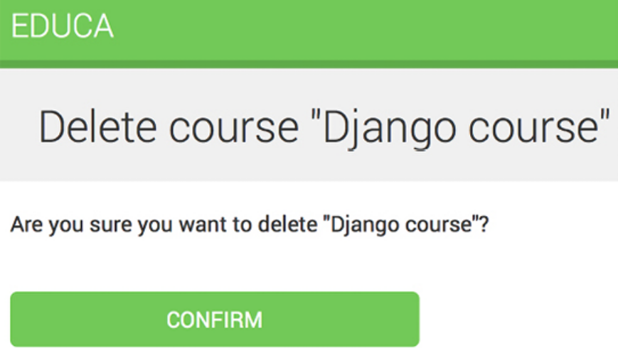
Figure 13.7: The Delete course confirmation page

Click the CONFIRM button. The course will be deleted and you will be redirected to the
course list page again.

Instructors can now create, edit, and delete courses. Next, you need to provide them with a CMS to add course modules and their contents. You will start by managing course modules.

Managing course modules and their contents
You are going to build a system to manage course modules and their contents. You will need to build forms that can be used for managing multiple modules per course and different types of content for each module. Both modules and their contents will have to follow a specific order and you should be able to reorder them using the CMS.

Using formsets for course modules
Django comes with an abstraction layer to work with multiple forms on the same page. These groups of forms are known as formsets. Formsets manage multiple instances of a certain Form or ModelForm . All forms are submitted at once and the formset takes care of the initial number of forms to display, limiting the maximum number of forms that can be submitted and validating all the forms.

Formsets include an is_valid() method to validate all forms at once. You can also provide initial data for the forms and specify how many additional empty forms to display. You can learn more about formsets at
https://docs.djangoproject.com/en/5.0/topics/forms/formsets/ and about model formsets at
https://docs.djangoproject.com/en/5.0/topics/forms/modelforms/#model-formsets.
Since a course is divided into a variable number of modules, it makes sense to use formsets to manage them. Create a forms.py file in the courses application directory and add the following code to it:
from django.forms.models import inlineformset_factory
from .models import Course, Module
ModuleFormSet = inlineformset_factory(
Course,
Module,
fields=['title', 'description'],
extra=2,
can_delete=True
)

This is the ModuleFormSet formset. You build it using the inlineformset_factory() function provided by Django. Inline formsets are a small abstraction on top of formsets that simplify working with related objects. This function allows you to build a model formset dynamically for the Module objects related to a Course object.

You use the following parameters to build the formset:

- fields : The fields that will be included in each form of the formset.

- extra : Allows you to set the number of empty extra forms to display in the formset.

- can_delete : If you set this to True , Django will include a Boolean field for each form that will be rendered as a checkbox input. It allows you to mark the objects that you want to delete.

Edit the views.py file of the courses application and add the following code to it:
from django.shortcuts import get_object_or_404, redirect
from django.views.generic.base import TemplateResponseMixin, Vie
from .forms import ModuleFormSet
class CourseModuleUpdateView(TemplateResponseMixin, View):
template_name = 'courses/manage/module/formset.html'
course = None
def get_formset(self, data=None):
return ModuleFormSet(instance=self.course, data=data)
def dispatch(self, request, pk):
self.course = get_object_or_404(
Course, id=pk, owner=request.user
)
return super().dispatch(request, pk)
def get(self, request, *args, **kwargs):
formset = self.get_formset()
return self.render_to_response(
{'course': self.course, 'formset': formset}
)
def post(self, request, *args, **kwargs):
formset = self.get_formset(data=request.POST)
if formset.is_valid():
formset.save()
return redirect('manage_course_list')
return self.render_to_response(
{'course': self.course, 'formset': formset}
)

The CourseModuleUpdateView view handles the formset to add, update, and delete modules for a specific course. This view inherits from the following mixins and views:

- TemplateResponseMixin : This mixin takes charge of rendering templates and returning an HTTP response. It requires a template_name attribute that indicates the template to be rendered and provides the render_to_response() method to pass it a context and render thetemplate.

- View : The basic class-based view provided by Django.

In this view, you implement the following methods:

- get_formset() : You define this method to avoid repeating the code to build the formset. You create a ModuleFormSet object for the given Course object with optional data.

- dispatch() : This method is provided by the View class. It takes an HTTP request and its parameters and attempts to delegate to a lowercase method that matches the HTTP method used. A GET request is delegated to the get() method and a POST request to post() ,respectively. In this method, you use the get_object_or_404() shortcut function to get the Course object for the given id parameter that belongs to the current user. You include this code in the dispatch() method because you need to retrieve the course for both GET and POST requests. You save it into the course attribute of the view to make it accessible to other methods.

- get() : Executed for GET requests. You build an empty ModuleFormSet formset and render it to the template together with the current Course object, using the render_to_response() method provided by TemplateResponseMixin .

- post() : Executed for POST requests. In this method, you perform the following actions:

1. You build a ModuleFormSet instance using the submitted data.

2. You execute the is_valid() method of the formset to validate all of its forms.

3. If the formset is valid, you save it by calling the save() method. At this point, any changes made, such as adding, updating, or marking modules for deletion, are applied to the database. Then, you redirect users to the manage_course_list URL. If the formset is not valid, you render the template to display any errors instead.

Edit the urls.py file of the courses application and add the following URL pattern to it:
path(
'<pk>/module/',
views.CourseModuleUpdateView.as_view(),
name='course_module_update'
),

Create a new directory inside the courses/manage/ template directory and name it module . Create a courses/manage/module/formset.html template and add the following code to it:
{% extends "base.html" %}
{% block title %}
Edit "{{ course.title }}"
{% endblock %}
{% block content %}
<h1>Edit "{{ course.title }}"</h1>
<div class="module">
<h2>Course modules</h2>
<form method="post">
{{ formset }}
{{ formset.management_form }}
{% csrf_token %}
<input type="submit" value="Save modules">
</form>
</div>
{% endblock %}

In this template, you create a <form> HTML element in which you include formset . You also include the management form for the formset with the variable {{ formset.management_form }} . The management form includes hidden fields to control the initial, total, minimum, and maximum number of forms.

Edit the courses/manage/course/list.html template and add the following link for the course_module_update URL below the course Edit and Delete links:
<a href="{% url "course_edit" course.id %}">Edit</a>
<a href="{% url "course_delete" course.id %}">Delete</a>
<a href="{% url "course_module_update" course.id %}">Edit module
You have included the link to edit the course modules.
Open http://127.0.0.1:8000/course/mine/ in your browser. Create a course and click the Edit modules link for it. You should see a formset, as follows:
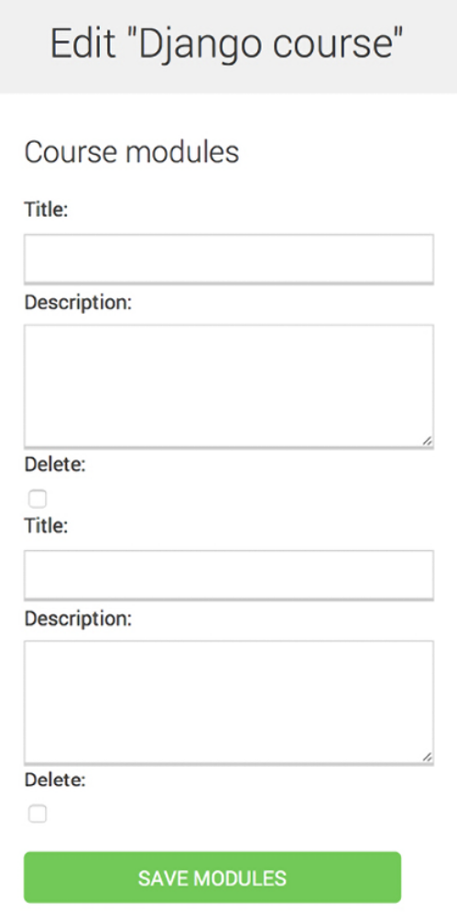
Figure 13.8: The course edit page, including the formset for course modules

The formset includes a form for each Module object contained in the course. After these, two empty extra forms are displayed because you set extra=2 for ModuleFormSet . When you save the formset, Django will include another two extra fields to add new modules.

You can see that formsets are incredibly useful for managing multiple instances of forms on a single page. Formsets simplify the process of collecting and validating data from sets of similar forms efficiently.
After understanding how formsets work, you will explore advanced form capabilities by creating forms dynamically that adapt to the various types of content that will be added to course modules.

Adding content to course modules
Now, you need a way to add content to course modules. You have four different types of content: text, video, image, and file. You could consider creating four different views to create content, with one form for each model. However, you are going to take a more versatile approach and create a view that handles creating or updating the objects of any content model. You will build the form for this view dynamically, according to the type of content the instructor wants to add to the course: Text , Video , Image , or
File .

Edit the views.py file of the courses application and add the following code to it:
from django.apps import apps
from django.forms.models import modelform_factory
from .models import Module, Content
class ContentCreateUpdateView(TemplateResponseMixin, View):
module = None
model = None
obj = None
template_name = 'courses/manage/content/form.html'
def get_model(self, model_name):
if model_name in ['text', 'video', 'image', 'file']:
return apps.get_model(
app_label='courses', model_name=model_name
)
return None
def get_form(self, model, *args, **kwargs):
Form = modelform_factory(
model, exclude=['owner', 'order', 'created', 'update
)
return Form(*args, **kwargs)
def dispatch(self, request, module_id, model_name, id=None):
self.module = get_object_or_404(
Module, id=module_id, course__owner=request.user
)
self.model = self.get_model(model_name)
if id:
self.obj = get_object_or_404(
self.model, id=id, owner=request.user
)
return super().dispatch(request, module_id, model_name,

This is the first part of ContentCreateUpdateView . It will allow you to create and update different models’ contents. This view defines the following methods:
- get_model() : Here, you check that the given model name is one of the four content models: Text , Video , Image , or File . Then, you use Django’s apps module to obtain the actual class for the given model name. If the given model name is not one of the valid ones, you return None .

- get_form() : You build a dynamic form using the modelform_factory() function of the form’s framework. Since you are going to build a form for the Text , Video , Image , and File models, you use the exclude parameter to specify the common fields to exclude from the form and
- let all other attributes be included automatically. By doing so, you don’t have to know which fields to include depending on the model.

- dispatch() : This receives the following URL parameters and stores the corresponding module, model, and content object as class attributes:

- module_id : The ID for the module that the content is/will be associated with.

- model_name : The model name of the content to create/update.

- id : The ID of the object that is being updated. It’s None to create new objects.

Add the following get() and post() methods to ContentCreateUpdateView :
def get(self, request, module_id, model_name, id=None):
form = self.get_form(self.model, instance=self.obj)
return self.render_to_response(
{'form': form, 'object': self.obj}
)
def post(self, request, module_id, model_name, id=None):
form = self.get_form(
self.model,
instance=self.obj,
data=request.POST,
files=request.FILES
)
if form.is_valid():
obj = form.save(commit=False)
obj.owner = request.user
obj.save()
if not id:
# new content
Content.objects.create(module=self.module, item=obj)
return redirect('module_content_list', self.module.id)
return self.render_to_response(
{'form': form, 'object': self.obj}
)

These methods are as follows:

- get() : Executed when a GET request is received. You build the model form for the Text , Video , Image , or File instance that is being updated. Otherwise, you pass no instance to create a new object since self.obj is None if no ID is provided.

- post() : Executed when a POST request is received. You build the model form, passing any submitted data and files to it. Then, you validate it. If the form is valid, you create a new object and assign request.user as its owner before saving it to the database. You check for the id parameter. If no ID is provided, you know the user is creating a new\ object instead of updating an existing one. If this is a new object, you create a content object for the given module and associate the new content with it.

Edit the urls.py file of the courses application and add the following URL patterns to it:
path(
'module/<int:module_id>/content/<model_name>/create/',
views.ContentCreateUpdateView.as_view(),
name='module_content_create'
),
path(
'module/<int:module_id>/content/<model_name>/<id>/',
views.ContentCreateUpdateView.as_view(),
name='module_content_update'
),

The new URL patterns are as follows:

- module_content_create : To create new text, video, image, or file objects and add them to a module. It includes the module_id and model_name parameters. The first one allows you to link the new content object to the given module. The latter specifies the content model for which to build the form.

- module_content_update : To update an existing text, video, image, or file object. It includes the module_id and model_name parameters and an id parameter to identify the content that is being updated.

Create a new directory inside the courses/manage/ template directory and name it content . Create the template courses/manage/content/form.html and add the following code to it:
{% extends "base.html" %}
{% block title %}
{% if object %}
Edit content "{{ object.title }}"
{% else %}
Add new content
{% endif %}
{% endblock %}
{% block content %}
<h1>
{% if object %}
Edit content "{{ object.title }}"
{% else %}
Add new content
{% endif %}
</h1>
<div class="module">
<h2>Course info</h2>
<form action="" method="post" enctype="multipart/form-data">
{{ form.as_p }}
{% csrf_token %}
<p><input type="submit" value="Save content"></p>
</form>
</div>
{% endblock %}

This is the template for the ContentCreateUpdateView view. In this template, you check whether an object variable is in the context. If object exists in the context, you are updating an existing object. Otherwise, you are creating a new object.

You include enctype="multipart/form-data" in the <form> HTML element because the form contains a file upload for the File and Image content models.

Run the development server, open http://127.0.0.1:8000/course/mine/ ,
click Edit modules for an existing course, and create a module.

Then, open the Python shell with the following command:
python manage.py shell

Obtain the ID of the most recently created module, as follows:
>>> from courses.models import Module
>>> Module.objects.latest('id').id
6

Run the development server and open http://127.0.0.1:8000/course/module/6/content/image/create/ in your browser, replacing the module ID with the one you obtained before. You will see the form to create an Image object, as follows:
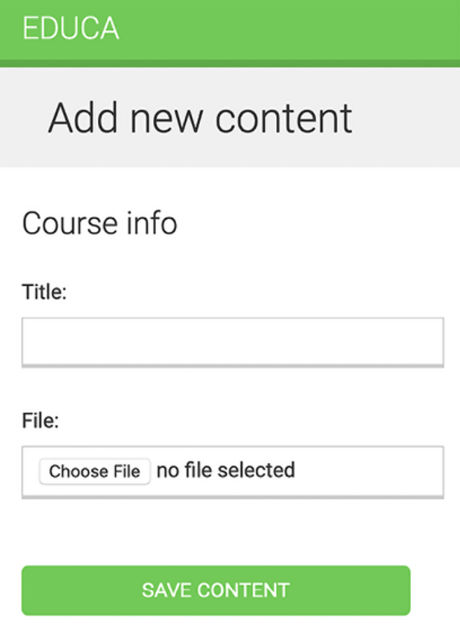
Figure 13.9: The course Add new content form

Don’t submit the form yet. If you try to do so, it will fail because you haven’t defined the module_content_list URL yet. You are going to create it in a bit.

You also need a view for deleting content. Edit the views.py file of the courses application and add the following code:
class ContentDeleteView(View):
def post(self, request, id):
content = get_object_or_404(
Content, id=id, module__course__owner=request.user
)
module = content.module
content.item.delete()
content.delete()
return redirect('module_content_list', module.id)

The ContentDeleteView class retrieves the content object with the given ID. It deletes the related Text , Video , Image , or File object. Finally, it deletes the content object and redirects the user to the module_content_list URL to list the other contents of the module.

Edit the urls.py file of the courses application and add the following URL
pattern to it:
path(
'content/<int:id>/delete/',
views.ContentDeleteView.as_view(),
name='module_content_delete'
),

Now, instructors can create, update, and delete content easily. The approach you have learned in this section is very useful for managing forms with diverse data in a generic manner. This method can be applied in other situations where a flexible solution is needed to handle data inputs.

In the next section, we are going to create the views and templates to display course modules and contents.

Managing modules and their contents
You have built views to create, edit, and delete course modules and their contents. Next, you need a view to display all modules for a course and list the contents of a specific module.

Edit the views.py file of the courses application and add the following code to it:
class ModuleContentListView(TemplateResponseMixin, View):
template_name = 'courses/manage/module/content_list.html'
def get(self, request, module_id):
module = get_object_or_404(
Module, id=module_id, course__owner=request.user
)
return self.render_to_response({'module': module})

This is the ModuleContentListView view. This view gets the Module object with the given ID that belongs to the current user and renders a template with the given module.

Edit the urls.py file of the courses application and add the following URL pattern to it:
path(
'module/<int:module_id>/',
views.ModuleContentListView.as_view(),
name='module_content_list'
),

Create a new template inside the templates/courses/manage/module/ directory and name it content_list.html . Add the following code to it:
{% extends "base.html" %}
{% block title %}
Module {{ module.order|add:1 }}: {{ module.title }}
{% endblock %}
{% block content %}
{% with course=module.course %}
<h1>Course "{{ course.title }}"</h1>
<div class="contents">
<h3>Modules</h3>
<ul id="modules">
{% for m in course.modules.all %}
<li data-id="{{ m.id }}" {% if m == module %}
class="selected"{% endif %}>
<a href="{% url "module_content_list" m.id %}">
<span>
Module <span class="order">{{ m.order|add:1 }}</sp
</span>
<br>
{{ m.title }}
</a>
</li>
{% empty %}
<li>No modules yet.</li>
{% endfor %}
</ul>
<p><a href="{% url "course_module_update" course.id %}">
Edit modules</a></p>
</div>
<div class="module">
<h2>Module {{ module.order|add:1 }}: {{ module.title }}</h2>
<h3>Module contents:</h3>
<div id="module-contents">
{% for content in module.contents.all %}
<div data-id="{{ content.id }}">
{% with item=content.item %}
<p>{{ item }}</p>
<a href="#">Edit</a>
<form action="{% url "module_content_delete" content.id %}"
method="post">
<input type="submit" value="Delete">
{% csrf_token %}
</form>
{% endwith %}
</div>
{% empty %}
<p>This module has no contents yet.</p>
{% endfor %}
</div>
<h3>Add new content:</h3>
<ul class="content-types">
<li>
<a href="{% url "module_content_create" module.id "text" %}">
Text
</a>
</li>
<li>
<a href="{% url "module_content_create" module.id "image" %}">
Image
</a>
</li>
<li>
<a href="{% url "module_content_create" module.id "video" %}">
Video
</a>
</li>
<li>
<a href="{% url "module_content_create" module.id "file" %}">
File
</a>
</li>
</ul>
</div>
{% endwith %}
{% endblock %}

Make sure that no template tag is split over multiple lines; the Django template engine expects the tags to be clearly defined and uninterrupted.

This is the template that displays all modules for a course and the contents of the selected module. You iterate over the course modules to display them in a sidebar. You iterate over a module’s contents and access content.item to get the related Text , Video , Image , or File object. You also include links to create new text, video, image, or file content.

You want to know which type of object each of the item objects is: Text , Video , Image , or File. You need the model name to build the URL to edit the object. Besides this, you could display each item in the template differently based on the type of content it is. You can get the model name for an object from the model’s Meta class by accessing the object’s _meta attribute. However, Django doesn’t allow you to access variables or attributes starting with an underscore in templates to prevent retrieving private attributes or calling private methods. You can solve this by writing a custom template filter.

Create the following file structure inside the courses application directory:
templatetags/
__init__.py
course.py

Edit the course.py module and add the following code to it:
from django import template
register = template.Library()
@register.filter
def model_name(obj):
try:
return obj._meta.model_name
except AttributeError:
return None

This is the model_name template filter. You can apply it in templates as object|model_name to get the model name for an object.

Edit the templates/courses/manage/module/content_list.html template and add the following line below the {% extends %} template tag:
{% load course %}

This will load the course template tags. Then, find the following lines:
<p>{{ item }}</p>
<a href="#">Edit</a>

Replace them with the following ones:
<p>{{ item }} ({{ item|model_name }})</p>
<a href="{% url "module_content_update" module.id item|model_nam
Edit
</a>

In the preceding code, you display the item model name in the template and
also use the model name to build the link to edit the object.

Edit the courses/manage/course/list.html template and add a link to the module_content_list URL, like this:
<a href="{% url "course_module_update" course.id %}">Edit module
{% if course.modules.count > 0 %}
<a href="{% url "module_content_list" course.modules.first.id %
Manage contents
</a>
{% endif %}

The new link allows users to access the contents of the first module of the course if there are any.

Stop the development server and run it again using the following command:
python manage.py runserver

By stopping and running the development server, you make sure that the course template tags file gets loaded.

Open http://127.0.0.1:8000/course/mine/ and click the Manage contents link for a course that contains at least one module. You will see a page like the following one:
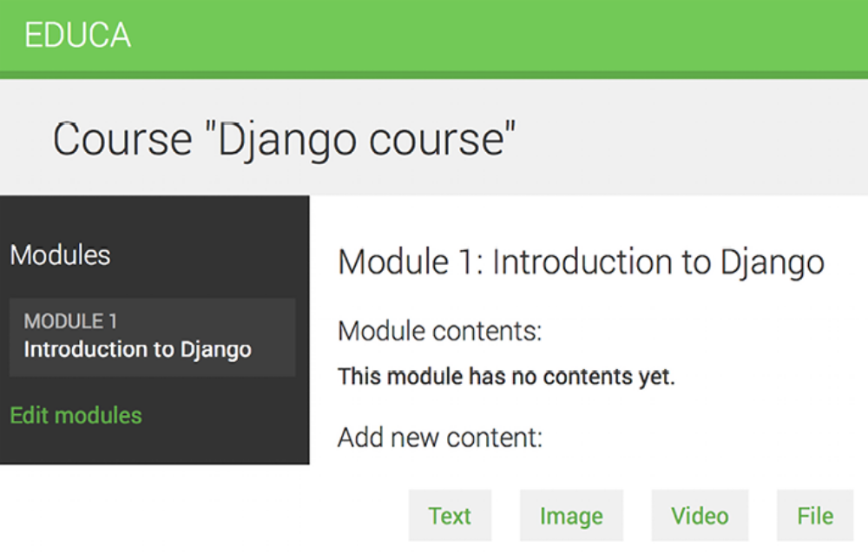
Figure 13.10: The page to manage course module contents

When you click on a module in the left sidebar, its contents are displayed in the main area. The template also includes links to add new text, video, image, or file content for the module being displayed.

Add a couple of different types of content to the module and look at the result. Module contents will appear below Module contents:
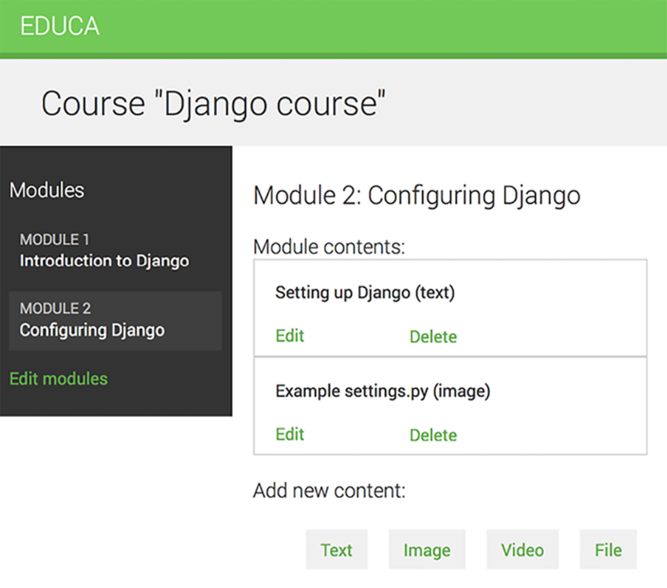
Figure 13.11: Managing different module contents

Next, we will allow course instructors to reorder modules and module contents with a simple drag-and-drop functionality.

Reordering modules and their contents
We will implement a JavaScript drag-and-drop functionality to let course instructors reorder the modules of a course by dragging them. Drag-and-drop enhances the user interface, offering a natural way to reorder elements that is more intuitive than using numbers or clicking buttons. It is also a time-saver for course instructors, who will be able to reorganize course modules and their contents easily.

To implement this feature, we will use the HTML5 Sortable library, which simplifies the process of creating sortable lists using the native HTML5 Drag and Drop API.

When users finish dragging a module, you will use the JavaScript Fetch API to send an asynchronous HTTP request to the server that stores the new module order.

You can read more information about the HTML5 Drag and Drop API at
https://www.w3schools.com/html/html5_draganddrop.as p. You can find examples built with the HTML5 Sortable library at
https://lukasoppermann.github.io/html5sortable/.
Documentation for the HTML5 Sortable library is available at
https://github.com/lukasoppermann/html5sortable.

Let’s implement the views to update the order of course modules and module contents.

Using mixins from djangobraces
django-braces is a third-party module that contains a collection of generic mixins for Django. These mixins provide additional features for class-based views that are useful for various common scenarios. You can see a list of all mixins provided by django-braces at https://djangobraces.readthedocs.io/.

You will use the following mixins of django-braces :

- CsrfExemptMixin : Used to avoid checking the cross-site request forgery (CSRF) token in the POST requests. You need this to perform AJAX POST requests without the need to pass a csrf_token .

- JsonRequestResponseMixin : Parses the request data as JSON and also serializes the response as JSON and returns an HTTP response with the application/json content type.

Install django-braces via pip using the following command:
python -m pip install django-braces==1.15.0

You need a view that receives the new order of module IDs encoded in JSON and updates the order accordingly. Edit the views.py file of the courses application and add the following code to it:
from braces.views import CsrfExemptMixin, JsonRequestResponseMix
class ModuleOrderView(CsrfExemptMixin, JsonRequestResponseMixin,
def post(self, request):
for id, order in self.request_json.items():
Module.objects.filter(
id=id, course__owner=request.user
).update(order=order)
return self.render_json_response({'saved': 'OK'})

This is the ModuleOrderView view, which allows you to update the order of course modules.

You can build a similar view to order a module’s contents. Add the following code to the views.py file:
class ContentOrderView(CsrfExemptMixin, JsonRequestResponseMixin
def post(self, request):
for id, order in self.request_json.items():
Content.objects.filter(
id=id, module__course__owner=request.user
).update(order=order)
return self.render_json_response({'saved': 'OK'})

Now, edit the urls.py file of the courses application and add the following URL patterns to it:
path(
'module/order/',
views.ModuleOrderView.as_view(),
name='module_order'
),
path(
'content/order/',
views.ContentOrderView.as_view(),
name='content_order'
),

Finally, you need to implement the drag-and-drop functionality in the template. We will use the HTML5 Sortable library, which simplifies the creation of sortable elements using the standard HTML Drag and Drop API. There are other JavaScript libraries that will allow you to achieve the same, but we chose HTML5 Sortable because it is lightweight and leverages the native HTML5 Drag and Drop API.

Edit the base.html template located in the templates/ directory of the courses application and add the following block highlighted in bold:
{% load static %}
<!DOCTYPE html>
<html>
<head>
# ...
</head>
<body>
<div id="header">
# ...
</div>
<div id="content">
{% block content %}
{% endblock %}
</div>
{% block include_js %}
{% endblock %}
<script>
document.addEventListener('DOMContentLoaded', (event) => {
// DOM loaded
{% block domready %}
{% endblock %}
})
</script>
</body>
</html>

This new block named include_js will allow you to insert JavaScript files into any template that extends the base.html template.

Next, edit the courses/manage/module/content_list.html template and add the following code highlighted in bold to the bottom of the template:
# ...
{% block content %}
# ...
{% endblock %}
{% block include_js %}
<script src="https://cdnjs.cloudflare.com/ajax/libs/html5sortab
{% endblock %}

In this code, you load the HTML5 Sortable library from a public content delivery network (CDN). Remember you loaded a JavaScript library from a CDN before in Chapter 6, Sharing Content on Your Website.

Now add the following domready block highlighted in bold to the
courses/manage/module/content_list.html template:
# ...
{% block content %}
# ...
{% endblock %}
{% block include_js %}
<script src="https://cdnjs.cloudflare.com/ajax/libs/html5sorta
{% endblock %}
{% block domready %}
var options = {
method: 'POST',
mode: 'same-origin'
}
const moduleOrderUrl = '{% url "module_order" %}';
{% endblock %}

In these new lines, you add JavaScript code to the {% block domready %} block that was defined in the event listener for the DOMContentLoaded event in the base.html template. This guarantees that your JavaScript code will be executed once the page has been loaded. With this code, you define the options for the HTTP request to reorder modules that you will implement next. You will send a POST request using the Fetch API to update the module order. The module_order URL path is built and stored in the JavaScript constant moduleOrderUrl .

Add the following code highlighted in bold to the domready block:
{% block domready %}
var options = {
method: 'POST',
mode: 'same-origin'
}
const moduleOrderUrl = '{% url "module_order" %}';
sortable('#modules', {
forcePlaceholderSize: true,
placeholderClass: 'placeholder'
});
{% endblock %}

In the new code, you define a sortable element for the HTML element with id="modules" , which is the module list in the sidebar. Remember that you use a CSS selector # to select the element with the given id . When you start dragging an item, the HTML5 Sortable library creates a placeholder item so that you can easily see where the element will be placed.

You set the forcePlacehoderSize option to true , to force the placeholder element to have a height, and you use placeholderClass to define the CSS class for the placeholder element. You use the class named placeholder that is defined in the css/base.css static file loaded in the base.html template.

Open http://127.0.0.1:8000/course/mine/ in your browser and click on Manage contents for any course. Now, you can drag and drop the course modules in the left sidebar, as in Figure 13.12:
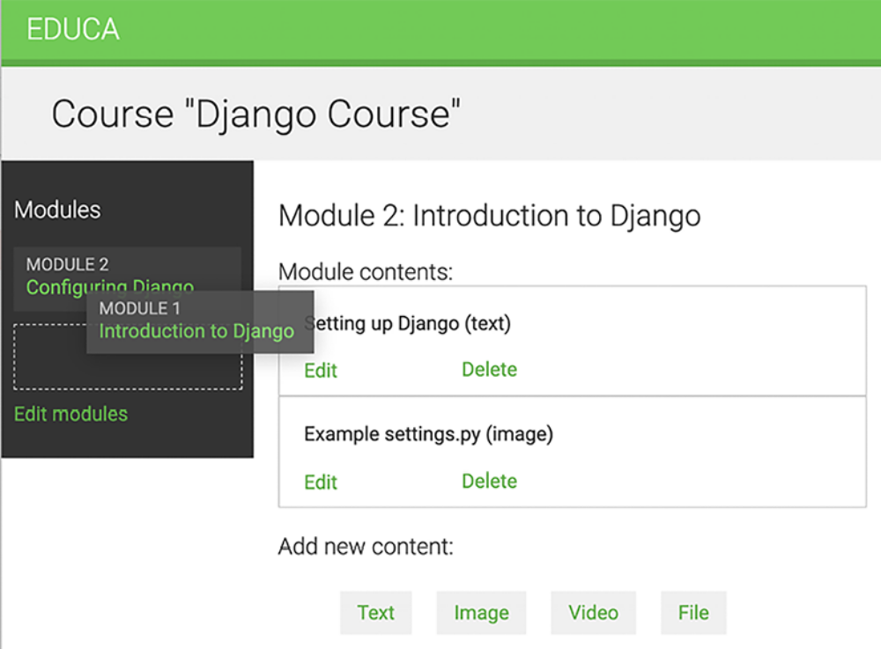
Figure 13.12: Reordering modules with the drag-and-drop functionality

While you drag the element, you will see the placeholder item created by the Sortable library, which has a dashed-line border. The placeholder element allows you to identify the position in which the dragged element will be dropped.

When you drag a module to a different position, you need to send an HTTP request to the server to store the new order. This can be done by attaching an event handler to the sortable element and sending a request to the server using the JavaScript Fetch API.

Edit the domready block of the courses/manage/module/content_list.html template and add the following code highlighted in bold:
{% block domready %}
var options = {
method: 'POST',
mode: 'same-origin'
}
const moduleOrderUrl = '{% url "module_order" %}';
sortable('#modules', {
forcePlaceholderSize: true,
placeholderClass: 'placeholder'
})[0].addEventListener('sortupdate', function(e) {
modulesOrder = {};
var modules = document.querySelectorAll('#modules li');
modules.forEach(function (module, index) {
// update module index
modulesOrder[module.dataset.id] = index;
// update index in HTML element
module.querySelector('.order').innerHTML = index + 1;
});
// add new order to the HTTP request options
options['body'] = JSON.stringify(modulesOrder);
// send HTTP request
fetch(moduleOrderUrl, options)
});
{% endblock %}

In the new code, an event listener is created for the sortupdate event of the sortable element. The sortupdate event is triggered when an element is dropped in a different position. The following tasks are performed in the event function:

1. An empty modulesOrder dictionary is created. The keys for this dictionary will be the module IDs, and the values will contain the index of each module.

2. The list elements of the #modules HTML element are selected with document.querySelectorAll() , using the #modules li CSS selector.

3. forEach() is used to iterate over each list element.

4. The new index for each module is stored in the modulesOrder dictionary. The ID of each module is retrieved from the HTML data-id attribute by accessing module.dataset.id . You use the ID as the key of the modulesOrder dictionary and the new index of the module as the
value.

5. The order displayed for each module is updated by selecting the element with the order CSS class. Since the index is zero-based and we want to display a one-based index, we add 1 to index .

6. A key named body is added to the options dictionary with the new order contained in modulesOrder . The JSON.stringify() method converts the JavaScript object into a JSON string. This is the body for the HTTP request to update the module order.

7. The Fetch API is used by creating a fetch() HTTP request to update the module order. The ModuleOrderView view that corresponds to the module_order URL takes care of updating the order of the modules.

You can now drag and drop modules. When you finish dragging a module, an HTTP request is sent to the module_order URL to update the order of the modules. If you refresh the page, the latest module order will be kept because it was updated in the database. Figure 13.13 shows a different order for the modules in the sidebar after sorting them using drag and drop:
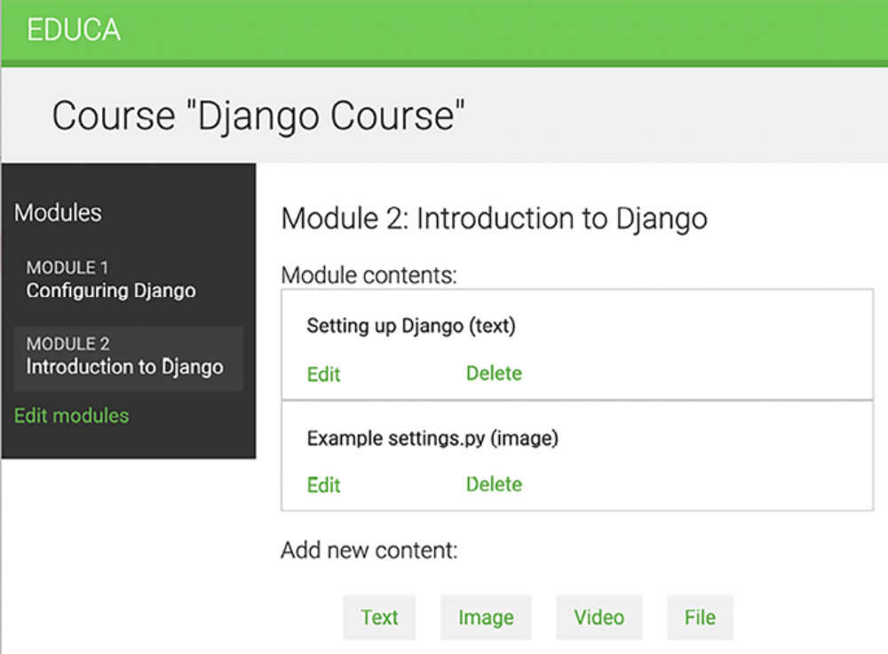
Figure 13.13: New order for modules after reordering them with drag and drop

If you run into any issues, remember to use your browser’s developer tools to debug JavaScript and HTTP requests. Usually, you can right-click anywhere on the website to open the contextual menu and click on Inspect or Inspect Element to access the web developer tools of your browser.

Let’s add the same drag-and-drop functionality to allow course instructors to sort module contents as well.

Edit the domready block of the courses/manage/module/content_list.html template and add the following code highlighted in bold:
{% block domready %}
// ...
const contentOrderUrl = '{% url "content_order" %}';
sortable('#module-contents', {
forcePlaceholderSize: true,
placeholderClass: 'placeholder'
})[0].addEventListener('sortupdate', function(e) {
contentOrder = {};
var contents = document.querySelectorAll('#module-contents d
contents.forEach(function (content, index) {
// update content index
contentOrder[content.dataset.id] = index;
});
// add new order to the HTTP request options
options['body'] = JSON.stringify(contentOrder);
// send HTTP request
fetch(contentOrderUrl, options)
});
{% endblock %}

In this case, you use the content_order URL instead of module_order and build the sortable functionality on the HTML element with the ID modulecontents. The functionality is mainly the same as for ordering course modules. In this case, you don’t need to update the numbering of the contents because they don’t include any visible index.

Now, you can drag and drop both modules and module contents, as in Figure 13.14:
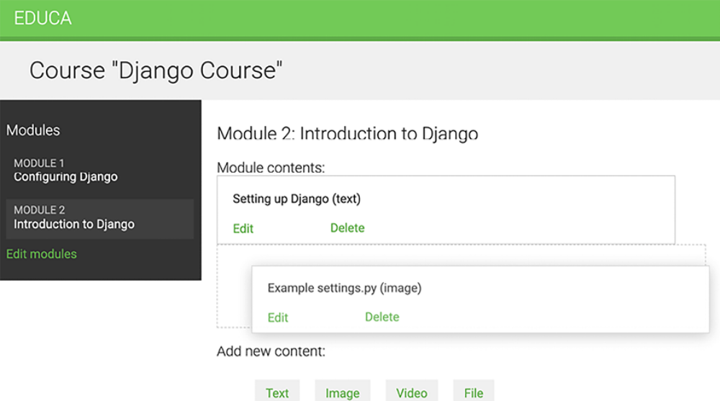
Figure 13.14: Reordering module contents with the drag-and-drop functionality

Great! You built a very versatile CMS for the course instructors.
Summary
In this chapter, you learned how to use class-based views and mixins to create a CMS. You acquired knowledge about reusability and modularity that you can apply to your future applications. You also worked with groups and permissions to restrict access to your views, gaining insights into security and how to control actions on data. You learned how to use formsets and model formsets to manage course modules and their content in a flexible manner. You also built a drag-and-drop functionality with JavaScript to reorder course modules and their contents with an improved user interface.

In the next chapter, you will create a student registration system and manage student enrollment in courses. You will also learn how to render different types of content and improve the performance of your application by caching content using Django’s cache framework.

Additional resources
The following resources provide additional information related to the topics
covered in this chapter:
Source code for this chapter: ( See page 909 )

